Comparing tRNA genes found by TRNAscan1.3 vs. tRNAscan2.0 from Trytryp genomes

> As you see in the VennDiagram we have four sets of:
- non-pseudo genes found by TSE1.3
- pseudo genes found by TSE1.3
- non-pseudo genes found by TSE2.0
- pseudo genes found by TSE2.0

As we see, Both gene-finders have found same 3511 genes with the exact same coordinates. There are genes that are considered as pseudo in one version and non-pseudo in the other version.
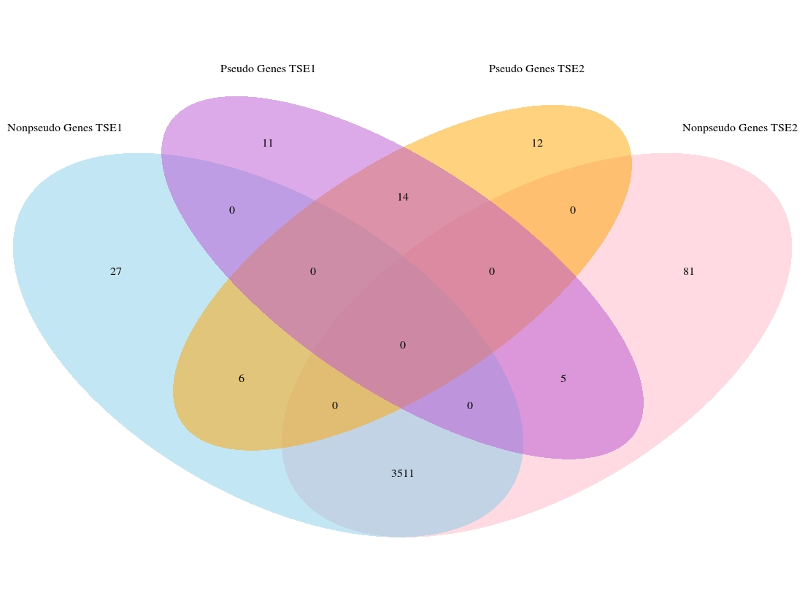

> In the fallowing plot we are comparing the scores of the genes found by both gene-finders.

- Non-pseudo genes found by both version of TSE(red)
- Genes found by both versions which are marked as non-pseudo in TSE1.3 and pseudo in TSE2.0(purple)
- Genes found by both versions which are marked as non-pseudo in TSE2.0 and pseudo in TSE1.3(blue)
- Genes found by both versions which are marked as pseudo in both versions(green)

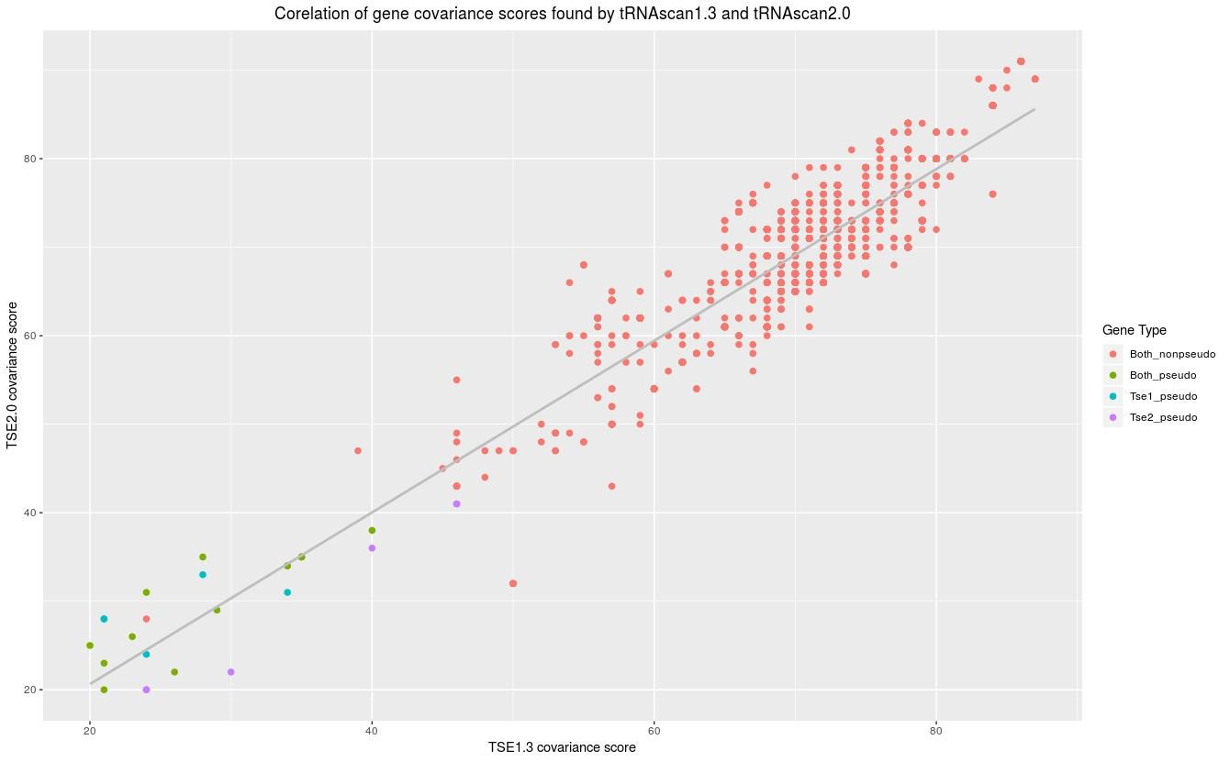

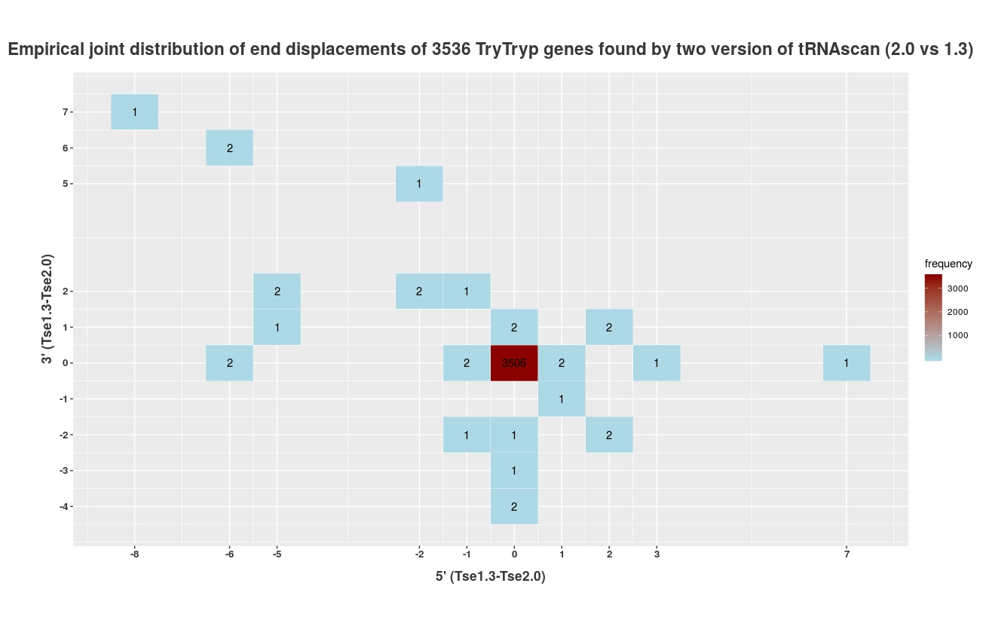
> A comparison of end-calling for TSE1.3 VS 2.0 for both pseudo and non-pseudo genes found by both versions.

